# Project – Mental Health in Tech Companies 2016

To save you time, here is the summary of this project. For a more detailed explanation of how our data was extracted, cleaned and visualized feel free to read past the TLDR.

## Summary TLDR:

The analyses of mental health in the workplace, particularly within the tech industry, reveal a complex landscape characterized by significant disparities, prevalent stigma, and the urgent need for comprehensive support systems.

Firstly, there is a notable reluctance to discuss mental health issues, This highlights a persistent stigma that organizations must address to foster a culture of openness and support.

Secondly, gender disparities in seeking mental health treatment are evident, as males are more likely to pursue help than females. This suggests the need for gender-sensitive strategies within organizations to encourage all employees to access mental health resources.

Additionally, despite the higher availability of workplace mental health support, the USA compared to the rest of the world, still faces significant mental health challenges, indicating that access alone is insufficient without addressing underlying issues and stigma.

Finally, high amounts of employees believe their productivity is affected. This underscores the critical need for tech companies to implement comprehensive mental health initiatives, such as wellness programs and counseling services, to create supportive environments that enhance employee well-being and productivity.

To summarize, addressing mental health in the workplace requires a multifaceted approach that includes raising awareness, reducing stigma, and providing accessible resources. By prioritizing mental health, organizations can foster a healthier, more inclusive workplace culture that ultimately benefits both employees and the overall productivity of the organization.

### Final Suggestions

* Make sure employees know that their workplace has a well-being program.
* Reinforce it by mentioning it in meetings and hanging posters around the office.
* Companies that don’t have one should implement one that is working.
* Or begin to research how a well-being initiative can benefit an individual.

--------------------------------------------------------------------------------------------------------

# Project Analysis

**Mental Health in Tech**: People working in tech are often at their desks for extended amounts of time. In this project, we explored how this trend correlates with mental health within the tech industry.

## Background:

Since 2009, every second Thursday of September is R U OK Day, a day to increase awareness and encourage conversations around mental health. We wanted to see if mental health was being addressed years later using a 2016 survey of individuals who work in the tech industry.

## Project Aim:

This project aims to uncover potential influences and trends on mental health and treatment-seeking behavior in the tech industry.

## **The main questions we used to guide our analysis were:**

1. Does mental health interfere with work?
2. Do males seek mental health treatments less often than females in tech companies?
3. Is mental health more prevalent in different regions? Does the USA have a bigger issue with mental health compared to other countries?
4. How do employees perceive their workplace culture regarding mental health?

## About Our Data

Our data was found from a Kaggle dataset called OSMI Metal Health in Tech Survey 2016.

Link: <https://www.kaggle.com/datasets/osmi/mental-health-in-tech-2016/data>

This data was gathered from a survey of individuals who volunteered and worked within the tech industry.

Questions ranged from whether they had a mental illness and were diagnosed by a medical professional or Does your workplace have any well-being programs.

## Potential Limitations

Upon cleaning the data, it was found that many individuals who did the survey were not from the same location. The vast majority of people who did the survey were from the USA and many of the other people who did the survey were from the outside. From this, we decided to use this as one of our questions and compare the USA to the rest of the world if mental health was more of a problem.

It should also be noted that 840 of the responses were from the USA and 593 were from outside the USA. From this, it was decided that we would use percentages to fairly display the results found from the data as if we were to use the whole numbers it may unfairly represent the USA compared to the rest of the world.

## Cleaning the data

From going through the data, many of the questions were very long and although very useful, we did not need all the questions to answer our questions.

Our first step when cleaning the data was to rename relevant questions that would help guide our analysis.

For example:

'Have you been diagnosed with a mental health condition by a medical professional?’

To

‘Diagnosed by professional?’

We checked for NaN values and removed those responses based on the question that we needed to answer. While keeping the original Dataframe intact in case we needed to go back and if we did not need to remove them based on what questions were being answered.

# TODO

* Analysis, graphs fix up. For each question/section.
* Conclusion
* Suggestions for improvement
* Original link to older project, mention I wish to expand further on this topic without affecting original github. Maybe not include???

## Analysis Question 1: Does mental health interfere with work?

First, we broke down our main question into 3 sub-questions to find a clearer answer to our main question.

Our sub-questions were:

* Do you think you have a mental disorder?
* Do you think your productivity is ever affected by mental health issues?
* What percentage of your work time is affected by mental health issues?

We first looked at the question: Do you think you have a mental disorder?

From what was found, 40.1% of respondents reported 'yes' which indicates that mental health is a critical issue that may need to be addressed in this industry.

The 22.8% who responded 'maybe' reflects a level of uncertainty or lack of awareness regarding mental health disorders. This could point to the need for more education and resources about mental health in the workplace.

The 37.1% who said 'no' indicates that individuals do not identify with having a mental health disorder. However, this figure is still lower than the percentage of those who believe they do, which may suggest that mental health issues are more common than perceived.

Given the high percentage of individuals acknowledging mental health disorders, it may be beneficial for tech companies to implement mental health initiatives, such as wellness programs, mental health days, and access to counseling services. This could help create a more supportive environment for employees.

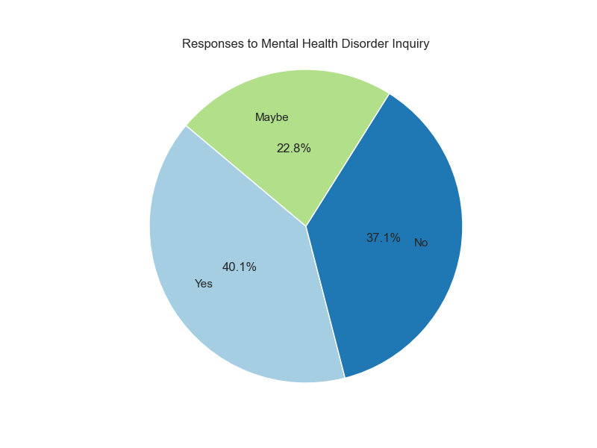

Our next question was: Do you think your productivity is ever affected by mental health issues?

From our findings when looking at this question, the majority (88.7%) of individuals with a mental disorder believe that their productivity is affected. Meanwhile, 7.3% are uncertain, and only 4.0% reported that it does not impact their productivity.

The fact that 88.7% of individuals believe their productivity is affected by their mental disorder indicates a strong awareness of the relationship between mental health and work performance. This suggests that mental health issues are a significant concern for a large portion of the workforce.

With only 4% reporting that their productivity is not impacted, it highlights that very few individuals feel unaffected by their mental health challenges. This could imply that mental health disorders are commonly perceived as disruptive to work.

The 7% of respondents who are uncertain about the impact on their productivity may reflect a lack of awareness or understanding of how their mental health affects their work. This uncertainty could be an opportunity for organizations to provide education and resources to help individuals better understand their situations.

The overwhelming majority indicating that their productivity is affected suggests a strong need for workplaces to address mental health issues proactively. This could include implementing mental health programs, providing access to counseling services, and creating a supportive work environment.

Pie graph - responses for Do you think your productivity is ever affected by mental health issues?
Yes - 88, no - 4, unsure - 7

Our final sub-question was: What percentage of your work time is affected by a mental health issue?

When it comes to the extent to which mental health disorders interfere with work, the responses were as follows:

* 39.1% indicated minimal influence (1-25%)
* 31.8% reported moderate influence (26-50%)
* 18.2% noted moderate to severe influence(51-75%)
* 10% believed that mental health disorders could have a substantial impact on their work (76-100%).

The fact that 39.1% of respondents reported minimal influence (1-25%) indicates that a significant portion of individuals may be managing their mental health challenges effectively.

With 31.8% reporting moderate influence, it indicates that a substantial number of individuals experience some level of disruption in their work due to mental health issues.

The 18.2% who noted moderate to severe influence, along with the 10% who believe in a severe impact (76-100%), highlights a critical area of concern. This indicates that almost 1/3 of the workforce is significantly affected, which could lead to decreased productivity, increased absenteeism, and higher turnover rates.

This raises the need for awareness and resources related to mental health in the workplace. Organizations might consider implementing mental health programs, providing training for managers, and fostering a supportive environment to help those who are affected.

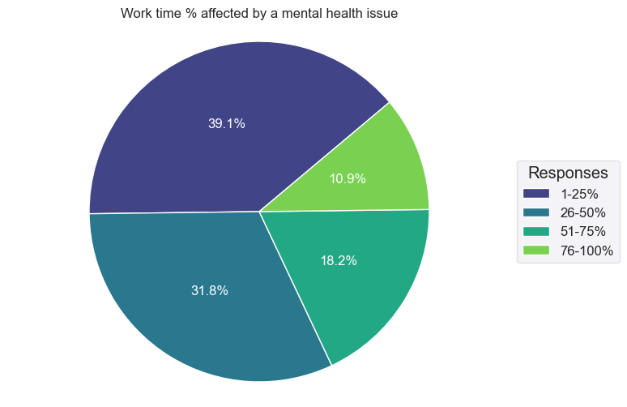

From our findings to answer the main question: Does mental health interfere with work? The answer is yes; about 90% of people with mental health disorders suggested that their work is affected to varying degrees, with about one-third reporting moderate to severe impacts.

## Analysis Question 2: Do males seek mental health treatment less often than females in the tech industry?

dddd